

College Of Arts & Sciences

**COSC 434 Advanced Web Programing**

**Final Report**

*Prepared by:*

***20210093-Karim Merhi 20210182-Ibrahim Dayraki***

***20220482-Majd Abou Ghoush***

*Submitted to:*

**Dr.Roaa Soloh**

**Spring 2024**

Contents

Introduction 3

Motivation 3

Our Project 3

Overview 3

Features 4

Technologies Utilized 7

Next Step 7

# Introduction

We were required to complete a project for the Advanced Web Programming course that involved creating a website's front end and backend with a specific goal in mind.

Accordingly, the project we chose to implement is a shoe e-commerce website.

Were the client is showcased various brands and shoe types to choose from with the facility to connect with both us the engineers or the Business “Website“ Owners.

This report summarizes our project, giving an overview of the motivation behind this project and the process we went through to reach our final project. It also includes

screenshots of our website and a briefing of the features we implemented on the website.

# Motivation

As teenagers, the mere thought of shoes sparked our fashion sense fueling a deep-seated passion for collecting and taking care of our sneakers. So, when the opportunity arose to create a website for our course project, excitement immediately lit up within us. Inspired by our shared love for shoes, we eagerly dove into the work, giving life to a project that embodies not just a course requirement but a genuine reflection of our enthusiasm for the fashion of shoes.

# Our Project

## Overview

Our eCommerce platform for shoes has a modern, polished look that facilitates easy online shoe shopping. It has an easy-to-use interface and is divided into

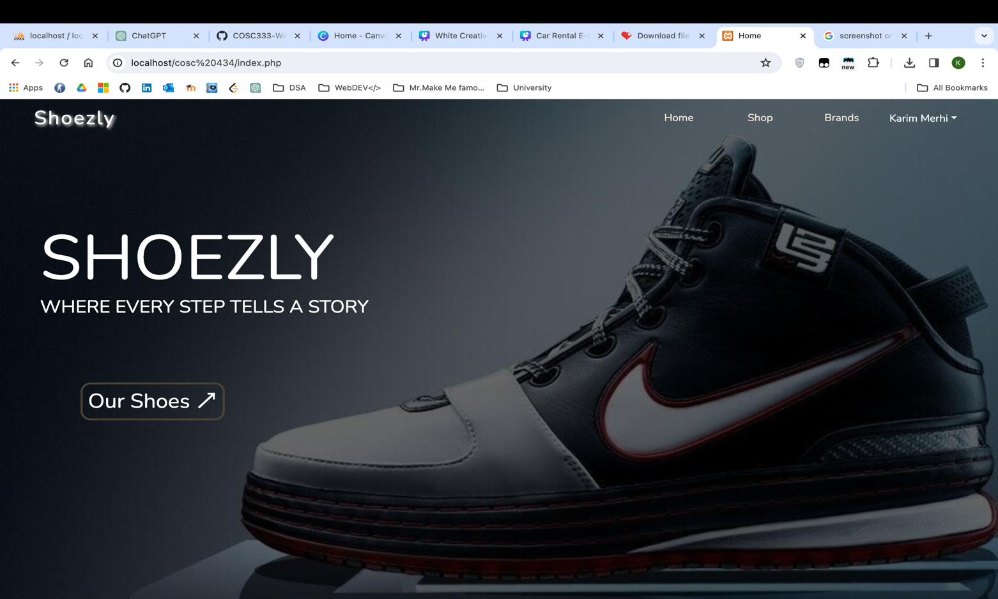sections for different option to filter shoes in addition to a login page. With its elegant brown-to-grey color scheme, the design complements our brand well and gives users a memorable and engaging experience.

*Figure I : Landing Page*

## Features

Our website includes many features that makes it standout to users. Among these features is the Email Sending to admin email. This is done by using the PHPMailer API.

*Figure II : Code for Email*

Another feature of our website is the responsive. We made sure that the website is device-friendly, and that our users can enjoy the website from the comfort of their handheld devices.

*Figure III : Responsive Garage*

Our website also features filters for cars. This means that the user can filter out the category they want to see.

*Figure IV : Filtered shop*

*Figure V : Database ER Diagram*

## Technologies Utilized



*Bootstrap JavaScript Visual Studio Code*



*HTML 5*

*jQuery*

*PHP*

*GitHub CSS*

# Next Step

After Our Delightful experience with COSC 333 and COSC 434 we decided to continue our track at university in software engineering and we will be taking React & Mobile Development Applications hopefully the following semester. Thanks for being a part of our journeys as you (Dr.Roaa Soloh) played a part in our orientation towards falling in love with software engineering and web development and we hope to complete this journey with your assistance.